**Covid-19 Dashboard**

Note: Since Google Data Studio business intelligence tool does not require any coding to create a dashboard. So following are the major steps involved to build a Covid-19 dashboard:

**Data Sources**

Data source plays a vitally important role in visualizing. So necessary data sources were uploaded for data visualization and building of the Covid-19 dashboard.

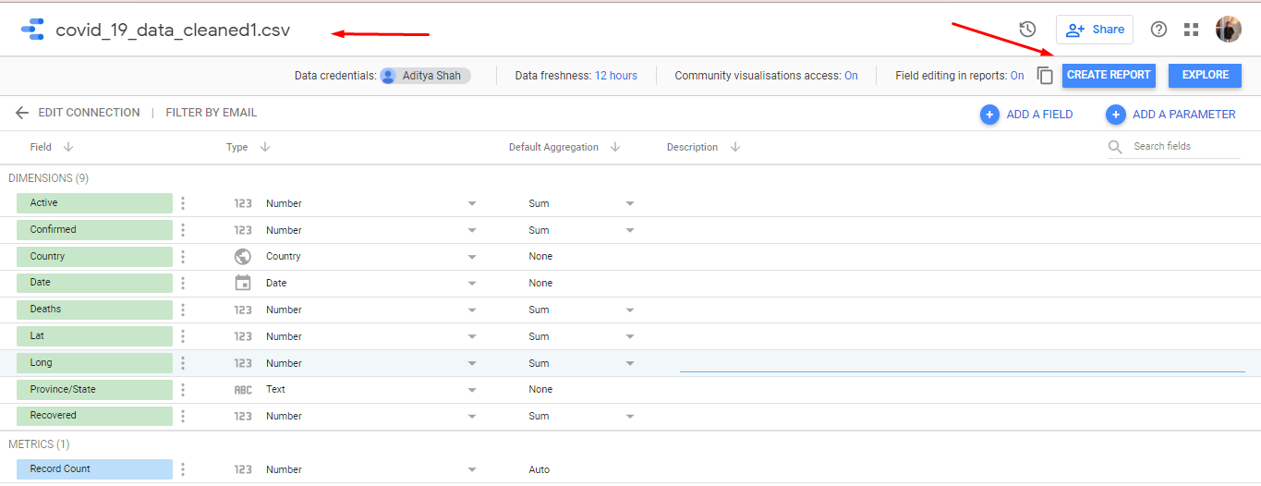

Figure . Uploading covid-19 cleaned data

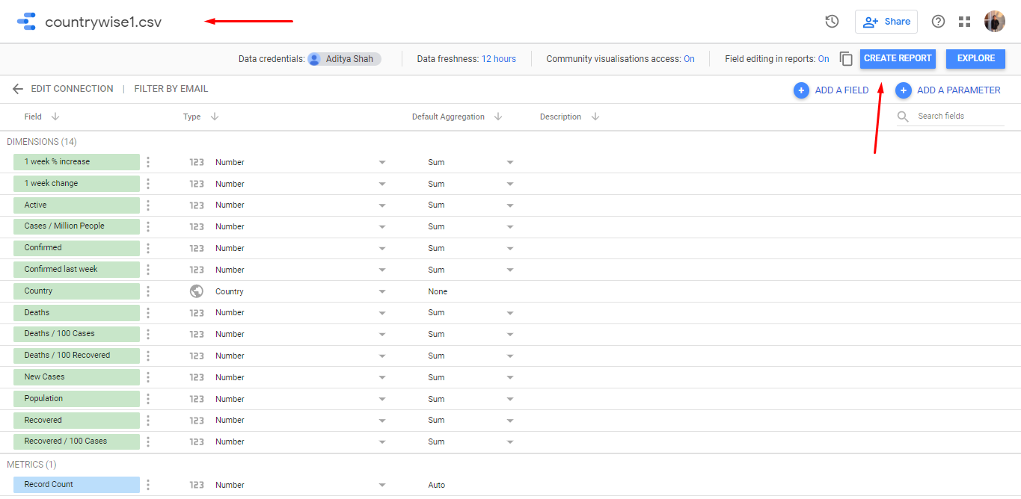

Figure . Uploading Country wise data

**Dashboard Layout**

Layout and size of Covid-19 dashboard was managed from layout section of the tool.

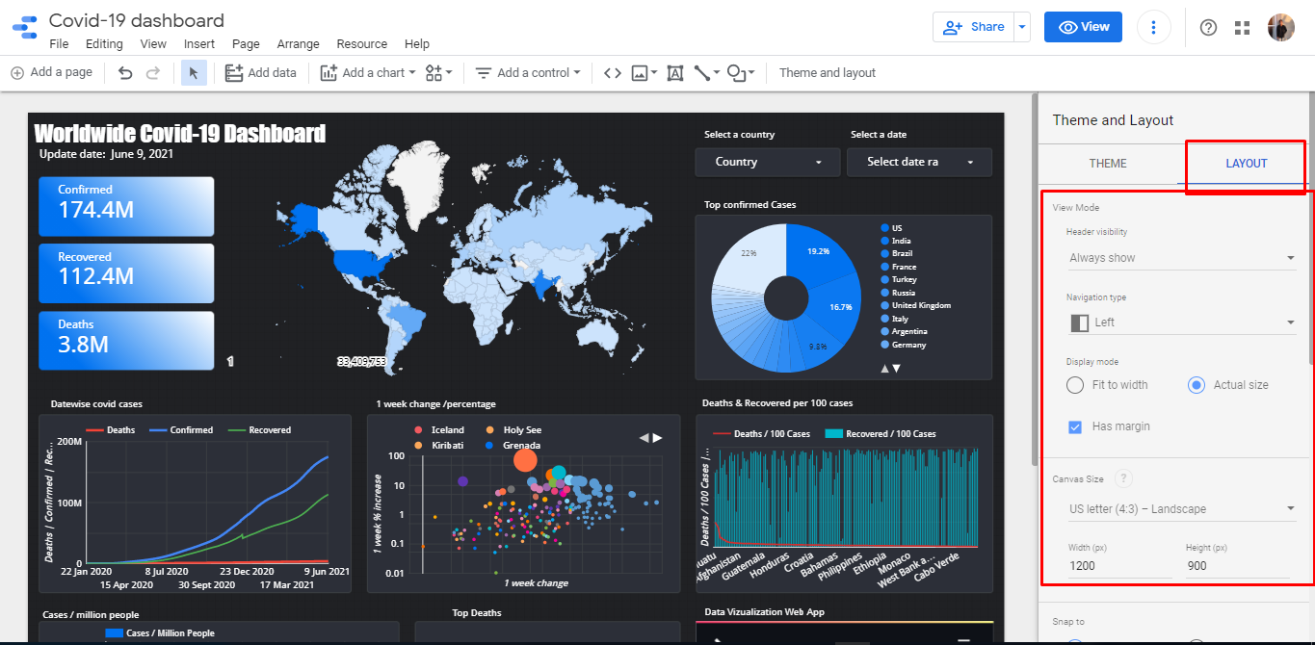

Figure . Layout of dashboard

**Score Card**

The three scorecards contain Confirmed, Recovered and Deaths cases it was built using a scorecard from the chart section of the tool, and its ouput and design were made from the data and style section of the tool as shown in figure (see figure 7).

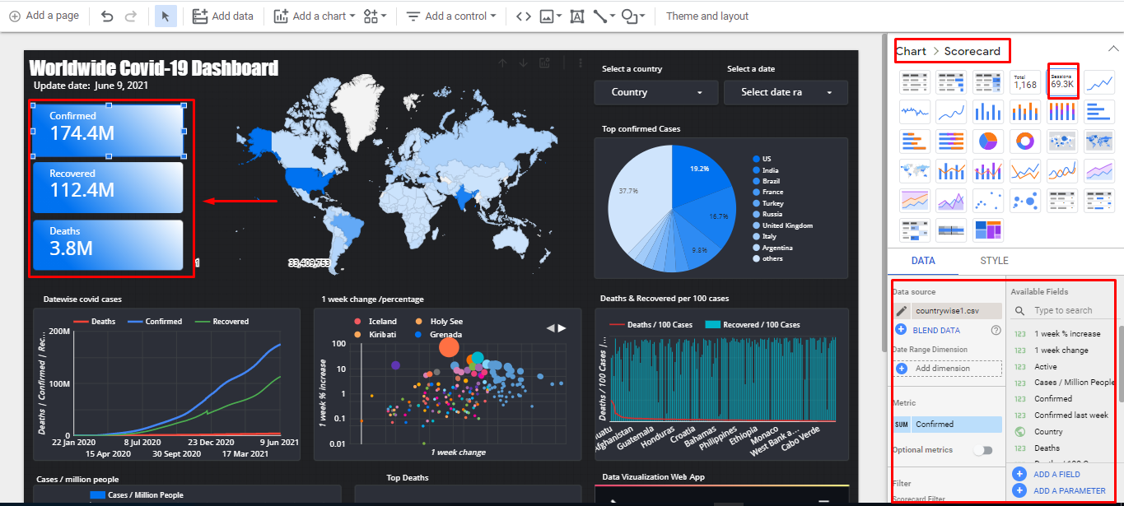

Figure 7. Score Card

**Geo map**

Geo map was created using geo chart and for its output and design, it was maintained from the data and style section of the tool.

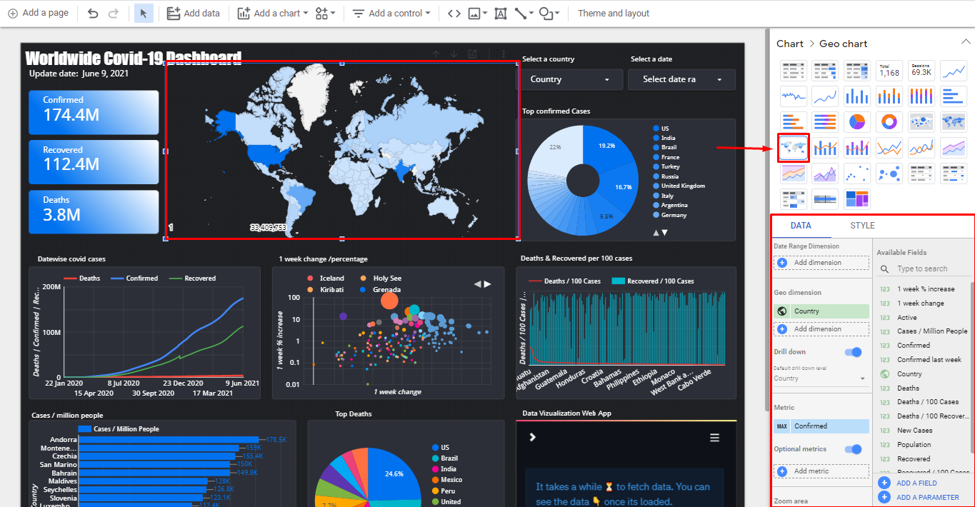

Figure . Geo map

**Drop down menu**

The selection of country and date dropdown menu was created from the drop-down list in the control section of the tool and its style and for output, it was managed in the data and style section of the tool as shown in the figure below(see figure 5).

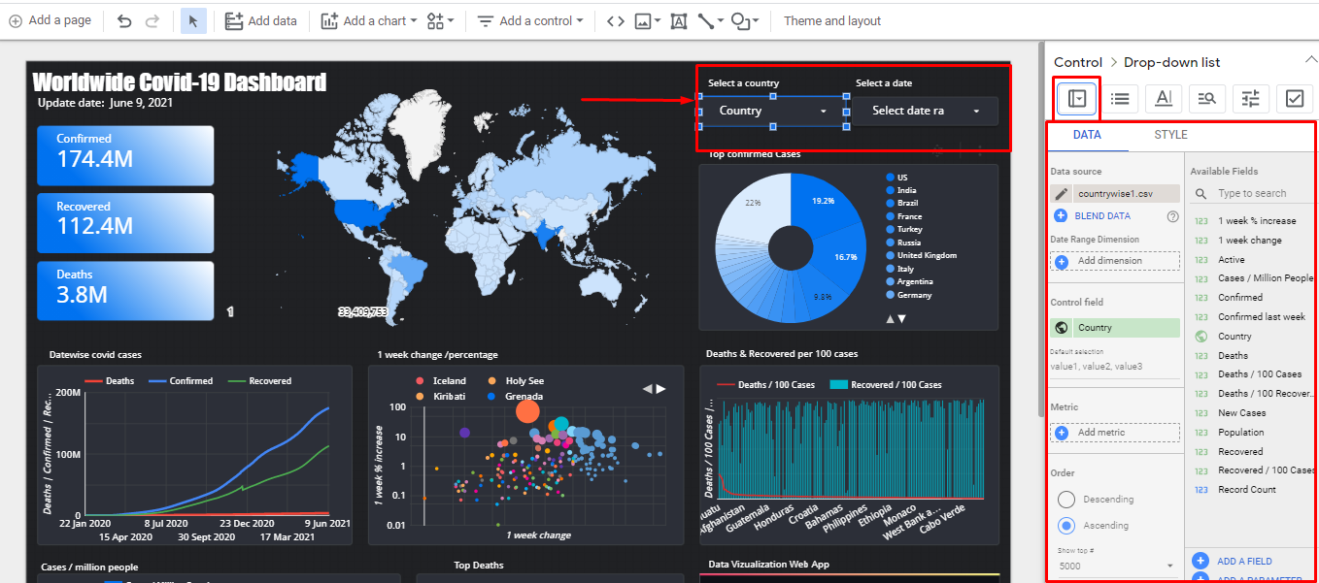

Figure . Dropdown menu

**Pie Chart**

Similarly for pie chart showing top confirmed cases were created from the chart section and for its output and style, it was designed in the data and style section of the tool.

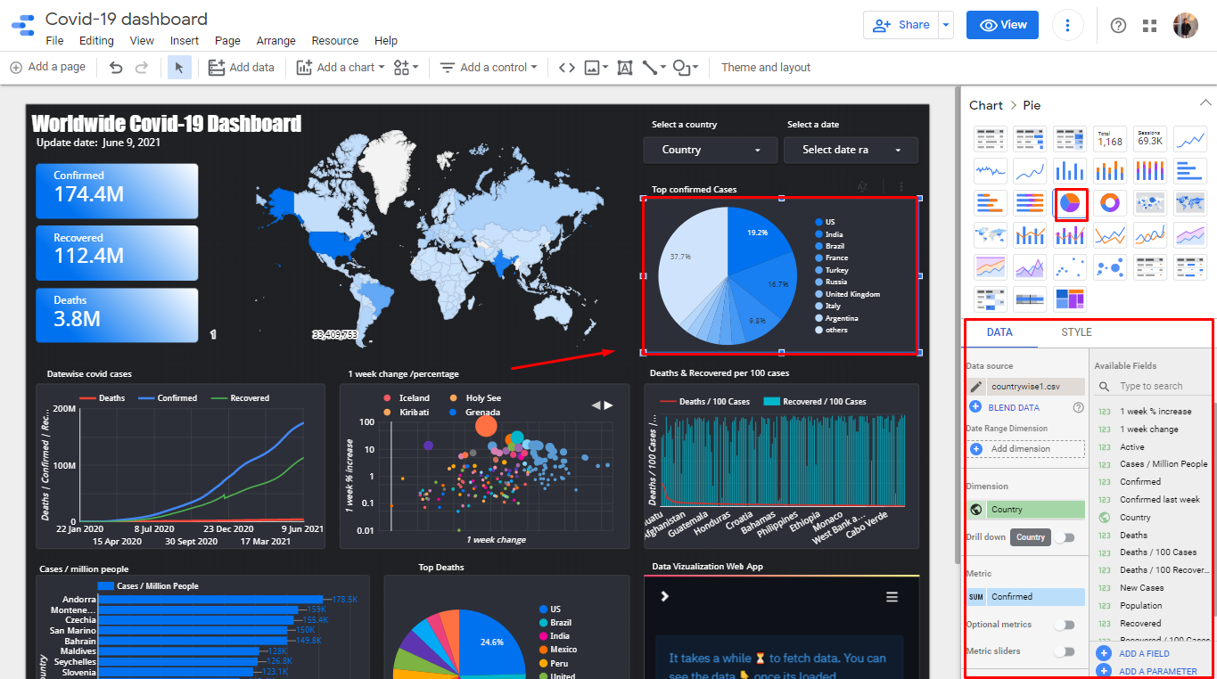

Figure . Pie chart

**All Graphical Components**

Likewise, Line Chart, Scatter plot, bar chart pie chart were similarly built from the chart section of the tool and its rendering output, data sources, and design was built from the data and style section of the tool.

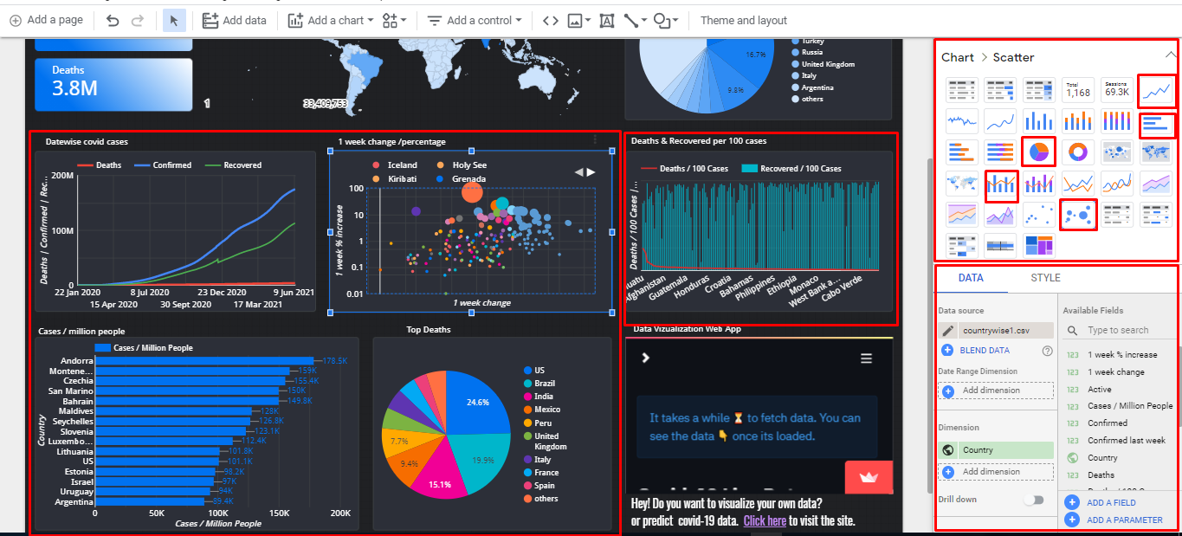

Figure . All graphical components